Disturbance and edge effect interactions in growth and allometric relations of a tropical forest herb.

(Afromomum paper)

Esaete, J., Eycott, A.E., Telford, R.J., Vandvik, V.

Story: At the edge, aframomum is abundant and big. Moving away from the edge, it is still big but less abundant. In the interior, the distribution becomes much more patchy and the plants are smaller. Damage is higher in the edges (1-3) than the interior –maybe the plants are too small and sparse for their predators tosurvive upon, or maybe they accumulate more tannins etc.. But what is the impact of compartment age?

Step1. Establish allometric relationships (including also population density ie nstems)
Step 2. Establish effect of forest age and edge distance on each growth measure
Step 2. See whether edge and age affect the allometric relationships (amy’s note to herself: test differences in slopes, use pseudopoisson for zero-inflated data?)

Results
- Allometric relationships
The mean height of plants in each plot was significantly positively assocaited with the mean leaf breadth, mean leaf length and mean number of leaves per plot (Figure 1).

Table 0. Model details for allometry based on perfall

Model | R2adj/AIC | F_{df1, df2}  Or  Null deviance_{df}, residual deviance_{df} | P or Dispersion | Is b sig?
StemLength~NumLeaves linear normal | 0.3362 | 1738_{1, 3249} | <0.001 | <0.001
NumLeaves~StemLength Linear Poisson | 19725 | xxx  4905.5₃₄₂₉ | 2.11 | <0.001

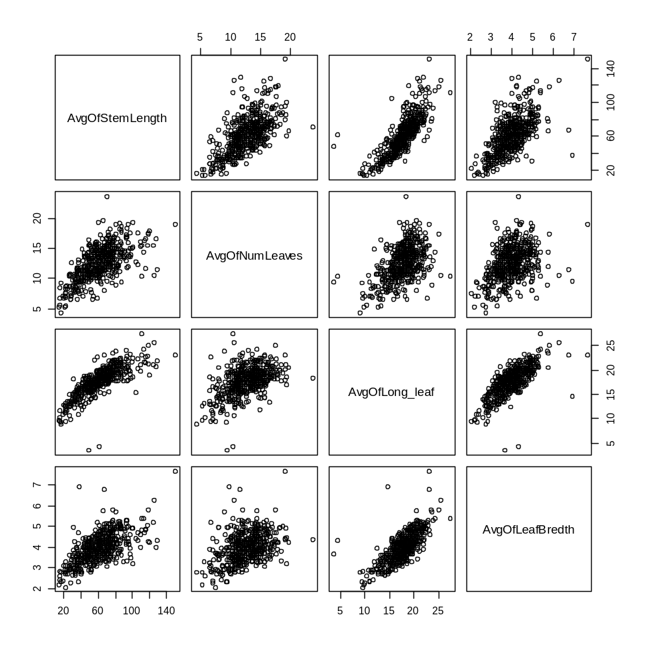

Figure 1. Allometric relationships between different size measures in Afromomum

- Edge and disturbance effects on size variables
The number of stems was significantly higher closer to the edge (Kruskall-Wallis chi-squared = 344.3662, df = 3, P < 0.001). Although the difference between distance groups was higher between 3 and 4 than between groups 1-3 (Figure 2), the difference between groups 1-3 was still significant (Kruskall-Wallis chi-squared = 18.8451, df = 2, P<0.001).
The number of stems varied with forest type (Kruskal-Wallis chi-squared = 25.6375, df = 2, P>0.001) but when the smallest category, old secondary, was not counted, the stem density in oldgrowth and young secondary were not significantly different (Kruskal-Wallis chi-squared = 0.6082, df = 1, P = 0.4355).

Table 1. Descriptive statistics for the number of stems

Division | Group | mean | sd | min | median | max | Proportion zeros | N subplots
By Forest type | Old growth
By Forest type | Old secondary
By Forest type | Young secondary
By Location (from edge) | 1 | 19.90 | 26.38 | 0 | 11 | 229 |  | 295
By Location (from edge) | 2 | 18.67 | 37.66 | 0 | 6 | 300 |  | 192
By Location (from edge) | 3 | 11.78 | 18.00 | 0 | 0 | 100 |  | 172
By Location (from edge) | 4 | 1.42 | 6.54 | 0 | 0 | 80 |  | 450

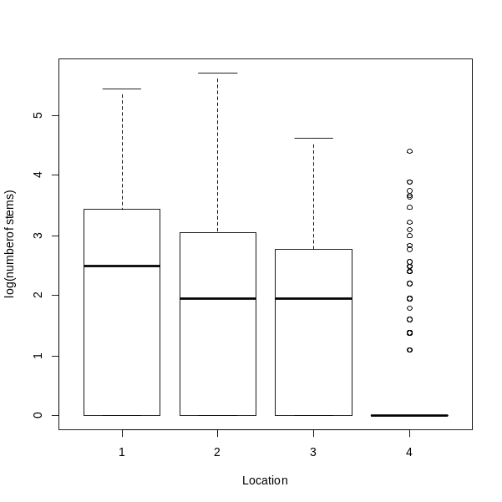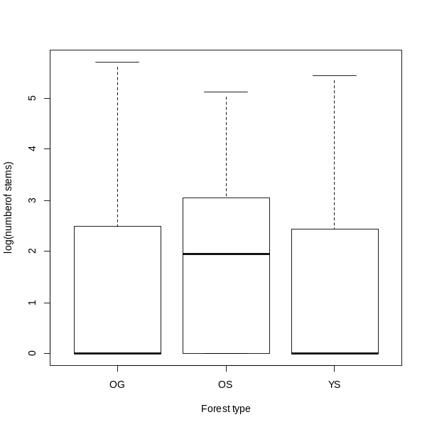

Figure 2. Boxplots of the number of stems in subplots in the different distance categories and forest types.

